# Lab: Factory reset a Palo Alto firewall

# Members: David, Andy

# Period 5 Cybersecurity

Step 1:

Console into the firewall and open the CLI in a PC. Then initiate startup in the firewall by unplugging it and plugging it back in. You should see the firewall beginning to boot in the CLI.

Step 2:

When prompted, type “maint” in the CLI to enter maintenance mode.

Step 3:

Press “continue” to move to the next screen.

Step 4:

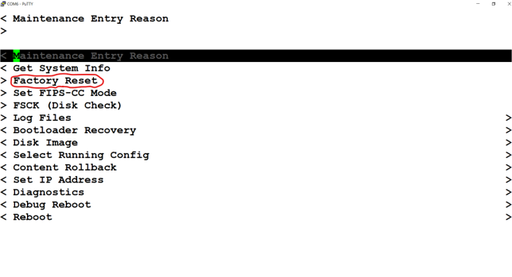

Use the arrow keys to select the “Factory Reset” option, and tap enter.

Step 5:

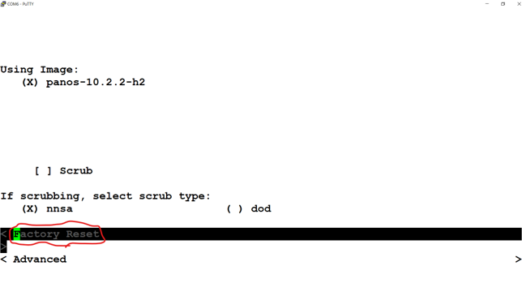

Use arrow keys and enter to select “Factory Reset” again to confirm your choice.

Step 6:

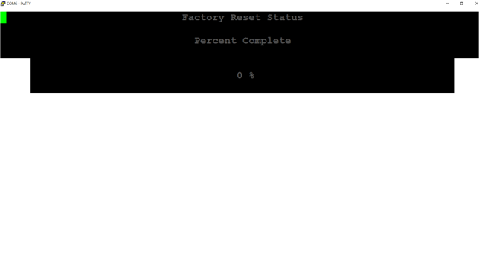

Wait until the factory reset process completes.